**Official Doc:**

https://core.telegram.org/bots/samples

https://github.com/python-telegram-bot/python-telegram-bot

https://github.com/eternnoir/pyTelegramBotAPI

**Online Tutorial:**

https://www.freecodecamp.org/news/learn-to-build-your-first-bot-in-telegram-with-python-4c99526765e4/

**Hosting Bot:**

https://github.com/python-telegram-bot/python-telegram-bot/wiki/Hosting-your-bot

https://github.com/python-telegram-bot/python-telegram-bot/wiki/Where-to-host-Telegram-Bots

**Possible Bot ideas - APIs:**

<https://data.gov.sg/dataset/realtime-weather-readings>

<https://github.com/ml5js/ml5-examples/tree/master>

<https://deepai.org/apis>

<https://deepai.org/machine-learning-model/fast-style-transfer>

Table of Content

**Install Python** **1**

**Install Python Libraries** **2**

**Register Bot** **3**

**Run the Program - your Bot will be online** **4**

## Install Python

<https://www.python.org/downloads/>

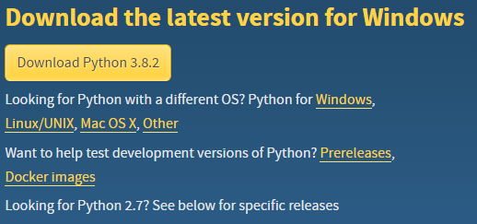

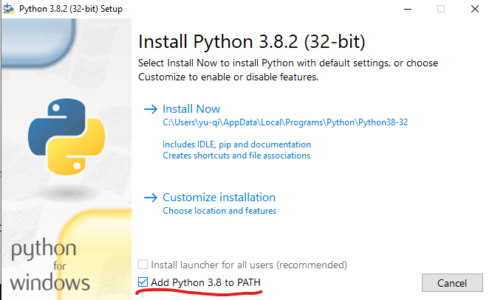

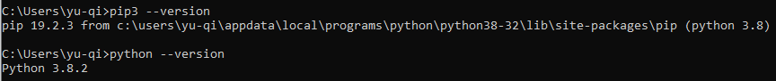

## Install Python Libraries

pip3 install python-telegram-bot

pip3 install requests

Just make sure “successfully installed” is shown. We can ignore the pip version warning

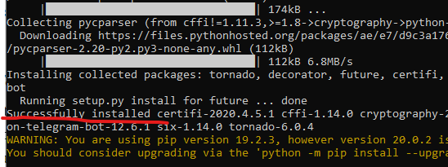

## Register Bot

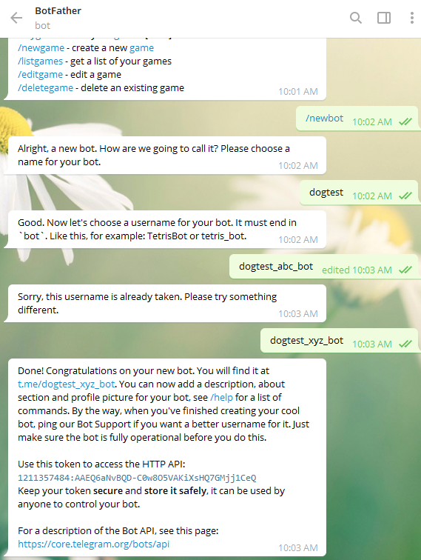

1211357484:AAEQ6aNvBQD-C0w8O5VAKiXsHQ7GMjj1CeQ

## Run the Program - your Bot will be online

from telegram.ext import Updater, InlineQueryHandler, CommandHandler

from telegram.ext.dispatcher import run_async

import requests

import re

def get_url():

contents = requests.get('https://random.dog/woof.json').json()

url = contents['url']

return url

def get_image_url():

allowed_extension = ['jpg','jpeg','png']

file_extension = ''

while file_extension not in allowed_extension:

url = get_url()

file_extension = re.search("([^.]*)$",url).group(1).lower()

return url

@run_async

def bop(update, context):

print("Getting dog picture...")

url = get_image_url()

chat_id = update.message.chat_id

context.bot.send_photo(chat_id=chat_id, photo=url)

def main():

updater = Updater('REPLACE_WITH_YOUR_TOKEN', use_context=True)

dp = updater.dispatcher

dp.add_handler(CommandHandler('bop',bop))

updater.start_polling()

updater.idle()

if __name__ == '__main__':

print("Starting the program...")

main()

python dog_pic_gen.py